- Name | Subject Class | Class | Index Number
 | 2BI



ANGLO-CHINESE JUNIOR COLLEGE
Preliminary Examination 2021

BIOLOGY 9744/02
26 August 2021
HIGHER 2 2 hours

For Examiner's Use
1
2
3
4
5
6
7
8
9
10
11
Total | 100
Paper 2 Structured Questions
READ THESE INSTRUCTIONS FIRST

Write your name, index number and class on the top of this page.
Write in dark blue or black pen.
You may use a soft pencil for any diagrams, graphs or rough working.
Do not use staples, glue or correction fluid.

Answer all questions in the spaces provided on the Question Paper.
No additional materials are required.

The use of an approved scientific calculator is expected, where appropriate.
You may lose marks if you do not show your working or if you do not use appropriate units.

The number of marks is given in brackets [ ] at the end of each question or part question.

this question paper consists of 28 printed pages.
- Human pancreatic cells produce proteases that act on the contents of the small intestine. An experiment was performed to track the pathway of protease synthesis and release. This involved incubating pancreatic cells for a brief period with amino acids that had been radioactively labelled. Radioactively-labelled proteins were detected in various organelles 120 minutes after incubation.
(a) | (i) | State two organelles which are likely to be found in abundance in a human pancreatic cell and outline the specific function of each named organelle in the cell.
- Mitochondrion / mitochondria;
- synthesises ATP required for exocytosis/ secretion of proteases/ enzymes/ proteins / protein synthesis;
R! metabolic activities/ cellular activities – too vague, see qns context
- Rough endoplasmic reticulum / Ribosomes on RER;
- (RER is) involved in the folding of polypeptide into specific 3D conformation / post-translational modification to form functional proteases/ enzymes/ proteins; /
(Ribosomes on RER) translate mRNA to form proteases/ enzymes/ proteins/polypeptide;
- Golgi apparatus;
- involved in post-translational chemical modification to form functional proteases/ enzymes/ proteins;
R! folding
- Secretory vesicle/ Transport vesicle;
- (Secretory vesicle are) involved in the transport of proteases/ enzymes/ proteins from Golgi apparatus to cell surface membrane for secretion;
/
(transport vesicles are) involved in the transport of proteases/ enzymes/ proteins from rough endoplasmic reticulum to Golgi apparatus for modification;
 |  | See at least once: proteases/ enzymes/ proteins
 |  | Any two organelles & corresponding function, @1m each, max 4m | [4]

 | (ii) | A student predicts that radioactively-labelled proteases will be detected at the nucleus 120 minutes after incubation because it is involved in protein synthesis.  Explain why the student’s prediction is incorrect.
- Only transcription of DNA coding for protease to form RNA takes place in the nucleus;
- Radioactivity will only be detected within ribosomes on RER / RER/ GA / transport / secretory vesicles (of endomembrane system); R! cytoplasm only
 |  | - Radioactively-labelled proteases do not enter the nucleus / secreted out of the cell after being synthesized at the ribosomes;
 |  | @1m each, max 2m | [2]

Fig. 1.1 shows the cross-section of a cell surface membrane.
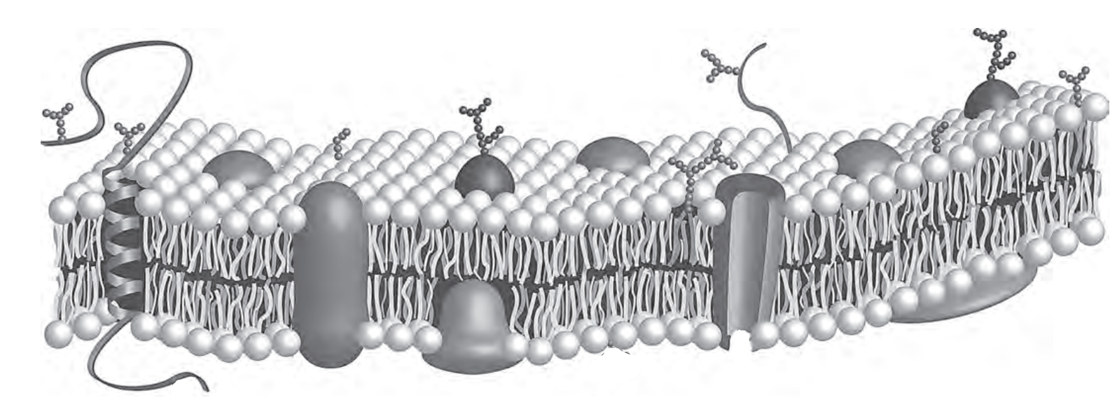
Ans for (b)(i)

Fig. 1.1
(b) | (i) | There is a higher Na⁺ concentration in the extracellular environment than in the intracellular environment.  Draw an arrow on Fig. 1.1 to show how Na⁺ diffuse across the cell surface membrane.
 |  | - Correct direction of arrow + through the protein channel;
 |  |  | [1]

 | (ii) | Explain your answer in (b)(i).
 |  | - Na⁺ is charged/ hydrophilic (R! polar), cannot pass through the hydrophobic core of the phospholipid bilayer;
 |  | - Requires a protein channel with a hydrophilic pore to move across the plasma membrane;
 |  |  | [2]

[Total: 9]
- Progressive telomere shortening has been linked to aging. In a study, telomere length in red blood cells of zebra finches is measured and recorded throughout their natural lifespan. The first measurement (shown as year = 0) was taken at 25 days, and measurements were taken at various points thereafter as shown in Fig. 2.1. Mean telomere length is represented as a ratio relative to a standard reference point.
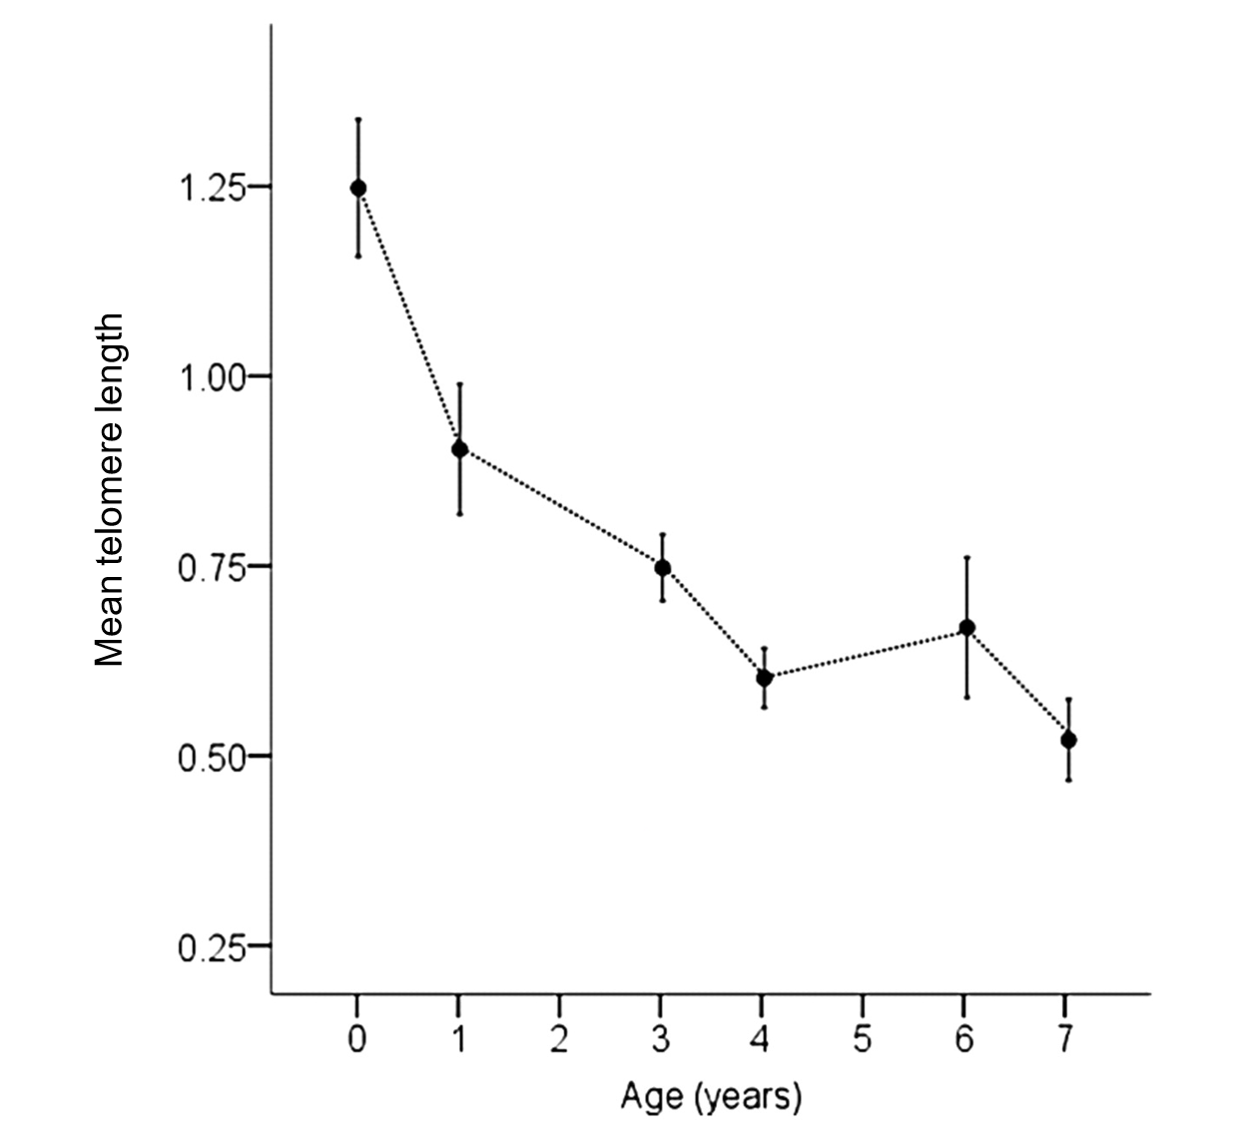
Fig. 2.1
(a) | (i) | Explain the relationship between telomere length and age of zebra finches.
 |  | - As age increases from 25 days/ 0 year to 7 years, mean telomere length decreases from 1.25 to 0.53 (A! 0.51 to 0.55);
 |  | - As the zebra finches age, the cells undergo multiple rounds of cell division and hence DNA replication;
 |  | - End replication problem occurs as DNA polymerase I cannot fill the gap / absence of an existing 3’ OH end at the 5’ end of lagging strand / newly synthesised strand / daughter strand;
 |  | @1m each | [3]

 | (ii) | Compare the structures of telomeres and centromeres.
Similarities
- Both are made up of repeating sequences/ repetitive DNA;
- Both are made up of non-coding sequences/ are non-coding;
Differences
- Telomere is found at the ends of linear chromosomes unlike centromere/ while centromeres are found at a point along the chromosomes/ not at the ends of chromosomes;
- Telomeres occur in two regions on a chromosome while centromere occurs at one region on a chromosome;
- Centromeres contain binding site complementary for kinetochore proteins to bind while telomeres do not have such binding sites;
- Telomeres can form loops while centromeres do not;
- AVP;
 |  | @1m each, 1 similarity + 1 difference | [2]

In embryonic stem (ES) cells, telomere length is maintained and the cells can continue to divide for long periods of time. This property is known as self-renewal.
(b) | (i) | Explain the significance of the ability of stem cells to renew themselves in living organisms.
 |  | - To maintain pool of undifferentiated/stem cells;
 |  | - So as to differentiate to form specialised cell population, to replace/ replenish cells lost through wear & tear/ injury/ disease; R! repair cells
 |  | @1m each, max 2 | [2]

 | (ii) | Suggest why telomeres are not shortened in ES cells despite numerous rounds of cell division.
 |  | - Telomerase gene is expressed / activation of telomerase which allows for maintenance of telomere length;
 |  | @1m each | [1]

[Total: 8]

- Fig. 3.1 is an illustration of the steps in DNA replication in prokaryotes.

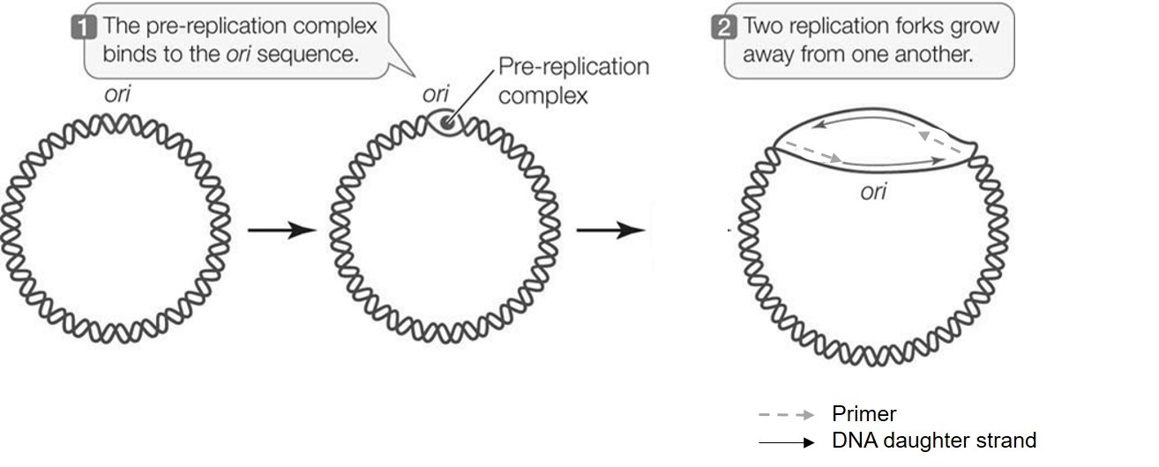
Fig. 3.1
(a) | Define the term “ori” in Fig. 3.1.
 | - Origin of replication is a region on the chromosome with specific nucleotide sequences where the process of replication begins (by the enzyme helicase) / unwind and unzip;
 | @ 1m | [1]

(b) | Primers and DNA daughter strands consist of different types of nucleotides.  Describe one way in which these nucleotides are similar in structure and explain why this feature is important for their functions.
 | Similarity in structure | Why this feature is important for its function
 | - They both have phosphate group bound to carbon-5 of pentose sugar; | - Allow formation of phosphodiester bond to form polynucleotides in DNA replication and transcription;
 | - They both have OH group bound to carbon-3 of pentose sugar;
 | - They both have nitrogenous bases bound to carbon-1 of pentose sugar; | - Complementary base pairing to form double stranded DNA and in some parts of RNA to form stable structure;
 | AVP: Both nucleotides have phosphate group, pentose sugar and nitrogenous base; (max 1)  1 pt for similarity in structure and 1 pt for importance @ 1m |  | [2]

(c) | With reference to Fig. 3.1, state and explain an error in this illustration of DNA replication in prokaryotes.
 | - Fig. 3.1 shows the synthesis of only leading strands / no lagging strands;
 | - Lagging strands are synthesised away from the replication fork / discontinously;
 | - As the two template strands are antiparallel;
 | - And DNA polymerase III can only add deoxyribonucleotides to a free 3’ OH end of growing DNA strand / DNA strand elongates in the 5’ to 3’ direction;
 | @ 1m, max 3 | [3]

Mutations in the top gene (the structural gene coding for E.coli DNA topoisomerase) may result in a number of impacts on DNA replication. In addition, it also has impacts on transcription.
(d) | Suggest why loss-of-function mutations in the top gene can also impact transcription.
 | - Mutations in top gene prevents topoisomerase from being synthesized/ Non-functional topoisomerase synthesized;
 | - No transient double-stranded break in the DNA molecule and resealing to prevent formation of supercoils / Formation of supercoils will occur;
 | - RNA polymerase cannot bind to promoter to initiate transcription;
 | @ 1m | [3]

[Total: 9]

- The fragile X mental retardation protein (FMRP) is essential in regulating the synthesis of neurone proteins which are important for normal brain function. Patients with fragile X syndrome (FXS) have very high number of CGG repeats at the beginning of the FMRP gene. These CGG repeats cause the DNA to fold into hairpins.
Fig 4.1 shows the expression of FMRP gene in a normal individual and in a patient with FXS.
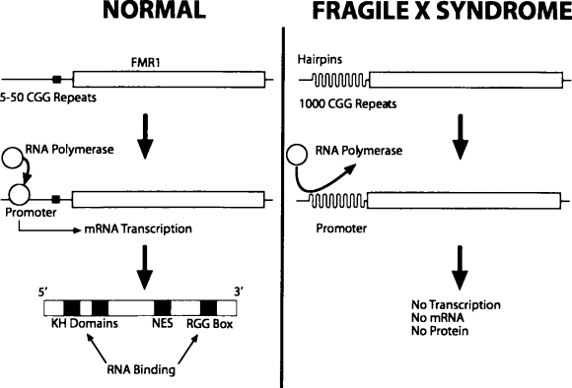
RNA-binding domains
FMRP gene
FMRP
zzzzzzzz
FMRP gene

FMRP gene
FMRP gene

Translation

FMRP

Normal Fragile X Syndrome (FXS)

Fig. 4.1

(a) | Explain the significance of the hairpin loops caused by the CGG repeats.
- The hairpin loops result in a change in 3D conformation of the DNA at the promoter preventing RNA polymerase from binding /
The hairpin loops reduces accessibility of RNA polymerase to the promoter;
 | - Preventing the initiation of transcription of the FMRP gene;
 | - No FMRP formed, resulting in FXS;
 | @ 1m | [3]

FMRP has RNA-binding domains which binds to mRNA coding for neurone proteins, preventing protein synthesis. The absence of functional FMRP leads to an increased rate of synthesis of neurone proteins which in turn results in FXS.

(b) | State which level of control of gene expression FMRP is involved in.
 | - Translational level
 |  | [1]

(c) | Some patients have a mild version of FXS, with 200-300 CGG repeats at the start of the FMRP gene. In these patients, a low number of FMRP can still be produced.  A student suggested that one possible way of treating mild FXS is to introduce enzymes which lengthen the poly-A tail of the FMRP mRNA. Explain if the student is right.
 | - Yes, the student is right;
 | - Lengthening the poly-A tail increases the stability / the half-life of the FMRP mRNA, resulting in more FMRP formed;
 | - Since FMRP prevents translation of neurone proteins, more FMRP would lead to a inhibit / lower rate of translation of neurone proteins, treating FXS;
 | @ 1m | [3]

(d) | Patients with FXS are able to produce normal gametes as meiosis is not affected by this condition.  Outline how haploid gametes are formed during meiosis.
 | - During anaphase I, homologous chromosomes are separated to halve the ploidy / halve the number of chromosomes;
 | - During anaphase II, sister chromatids are separated to form haploid gametes which are half the DNA content;
 | @ 1m | [2]

[Total: 9]

- A study was done to measure the expression of the structural genes of the lac operon in various mutant bacterial strain in the absence of lactose. The bacterial strains lacI⁺ and lacI– have the regulatory gene lacI present and deleted respectively. A positive measurement refers to the presence of the products in Table 5.1.
Table 5.1
strain | amount of β-galactosidase/ AU | amount of lactose permease/ AU
lacI⁺ | 0.005 | 0
lacI– | 2.022 | 0.1238
lacI– lacy– | 1.082 | 0

(a) | With reference to the lac operon, distinguish between a structural gene and a regulatory gene.
- A structural gene such as lacZ codes for β-galactosidase which hydrolyses lactose /
A structural gene such as lacY codes for lactose permease which transports lactose into the cell;
 | - A regulatory gene such as lacI codes for lac repressor, that regulates transcription of the lac operon;
 | @ 1m | [2] [2]

(b) | Explain the difference in the amount of β-galactosidase in the bacterial strains lacl⁺ and lacI–.
 | - The amount of β-galactosidase in the bacteria strains lacI⁺ is 0.005 AU which is lower than lacI⁻ is 2.022 AU;
 | - In the absence of lacI gene, no lac repressor protein is synthesized / in the presence of lacI gene, lac repressor protein is synthesised;
 | - Hence, repressor protein is unable to bind to the operator, allowing RNA polymerase to bind to promoter / repressor protein binds to the operator, preventing RNA polymerase to bind to promoter;
 | - Structural genes are expressed / structural genes not expressed;
 | @ 1m | [4]

(c) | In the bacterial strain lacl⁺, minute amount of β-galactosidase could still be detected, unlike lactose permease which was undetected. Suggest why the amount of lactose permease is not measurable in some of the bacteria strains.
 | - The amount of lactose permease produced is lower than the detectable threshold of measuring instrument;
- Some bacteria strains do not have this protein/ express other similar proteins instead;
- AVP;
 | @ 1m | [1]

In the presence of glucose, bacteria strains preferably use glucose as the respiratory substrate. Glucose, stored in the form of glycogen in the liver, is also an important respiratory substrate in humans.
(d) | Describe how the structure of glycogen relates to its function as an energy storage molecule.
 |  | [3]

Structure of glycogen | Function as storage molecules
- Glycogen (A! polysaccharide) is composed of several hundreds or thousands of / many glucose molecules; | - Upon hydrolysis, a large number of glucose molecules / respiratory substrates are released, to produce ATP for metabolic reactions;
- For each molecule, most of the hydrophilic OH groups of the glucose residues project into the interior of the helices and form hydrogen bonds with one another; | - Each molecule is very large so it does not easily diffuse out of cells;  - Hydroxyl groups are not available to form hydrogen bonds with water, resulting in starch being insoluble in water;  - They can be stored in large quantities without affecting the osmotic potential of cells;
- Molecules are helical in structure;  - Glycogen is highly branched; | - Allow glycogen to be compacted, enables greater amount of carbohydrates can be stored per unit volume;  - Branched structure of amylopectin and glycogen also allows many enzymes / large surface area for enzymes to act on it at any one time to release glucose quickly, so that rate of respiration (is increased;
@ least one structure linked accurately to one function, max 3
[Total: 10]

- Bacteria is a diverse group of organisms. Bacteria species can be categorised into Gram-negative or Gram-positive. Fig. 6.1 shows the membranes and cell walls of these two types of bacteria.
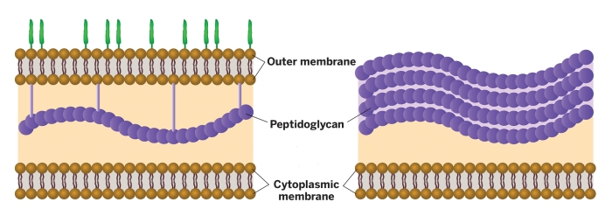
Gram-negative
Gram-positive

Cell wall

Fig. 6.1
(a) | Name the main component of the bacterial cell wall.
 | - The bacterial cell wall is made up of peptidoglycan;
 |  | [1]

Unlike eukaryotic organisms, bacteria do not contain mitochondria but are still able to carry out respiration. Fig. 6.2 shows the different proteins embedded within the membranes in a Gram-negative bacteria.
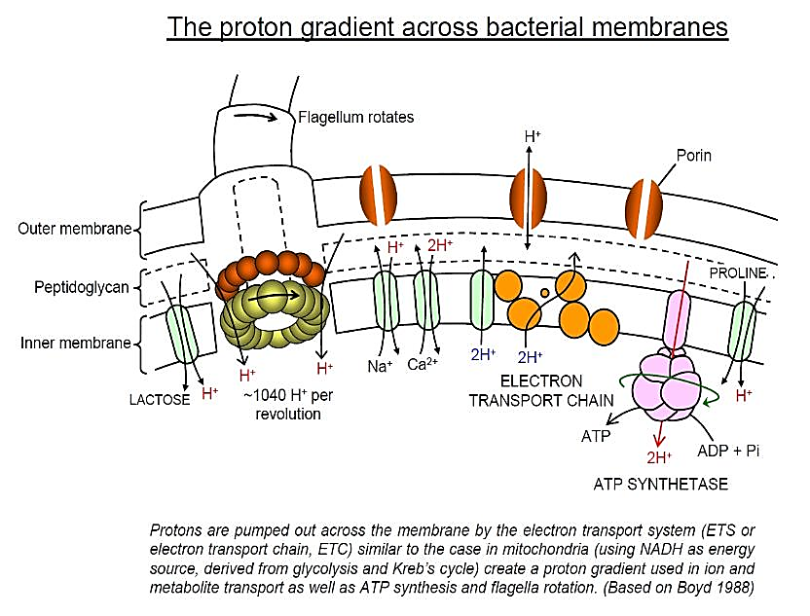
ATP SYNTHASE
Outer membrane
Periplasm
Cytoplasmic membrane
Fig. 6.2
(b) | (i) | With reference to Fig. 6.2, explain how the structure of the membrane allows the bacteria to undergo respiration.
 |  | - Hydrophobic core of the phospholipid bilayer of the membrane is impermeable to protons;
 |  | - Allows for the formation of a proton pool;
 |  | - Membrane is arranged in a phospholipid bilayer held together by weak hydrophobic interactions;
 |  | - Allows for embedment of electron transport chain/electron carriers and ATP synthase within the cytoplasmic membrane;
 |  | - Electron carriers accepts high energy electrons from hydrogen carriers which is passed down the system to release energy;
 |  | - The energy released in used to pump protons across the cytoplasmic membrane, allowing the proton pool to form in the periplasm;
 |  | - The protons diffuse down a concentration gradient through the ATP synthase for the chemiosmotic synthesis of ATP / oxidative phosphorylation;
 |  |  | [4]

 | (ii) | The Endosymbiotic Theory states that eukaryotic organelles like the mitochondria originated from prokaryotic microbes. The prokaryotic microbe was thought to be engulfed by a eukaryotic cell.  It was hypothesised that the prokaryotic microbe related to the Endosymbiotic Theory was a Gram-negative bacteria. Discuss if the information above supports this.
 |  | Does not support
 |  | - Gram-negative bacteria have double membranes, if it was engulfed by the eukaryotic cell, three membranes would have resulted;
 |  | - Presence of channel proteins/porins specific for protons on the outer membrane of the bacteria, suggesting that the membrane is permeable to protons (which is needed for formation of proton pool);
 |  | Support
 |  | - Presence of electron carriers of the electron transport chain and ATP synthase on inner membrane of the mitochondria is same as that of the inner membrane of gram-negative bacteria;
 |  | - Presence of an intermembrane space / periplasm where there is the accumulation of protons as a proton pool;
 |  | 1m for support, 1m for against | [2]

(c) | Some bacteria can respire anaerobically in low oxygen conditions. Bacteria respiring in low oxygen conditions produce lactate.  Outline the processes leading to the formation of lactate.
 | - Glucose is broken down to form pyruvate during glycolysis;
 | - Pyruvate is reduced to lactate, converting NADH to NAD⁺; | [2]

[Total: 9]

- Escherichia coli is a common human food contaminant. An E. coli strain carrying the aphA1 and aphA2 genes is resistant to the antibiotic kanamycin.
(a) | Describe the conditions needed for aphA1 and aphA2 genes to be transferred to other E. coli cells by transformation.
 | 1. Recipient cells must be competent / secrete the competence factor;
 | 2. DNA containing the aphA1 and aphA2 genes must be exogenous / present in the environment;
 | 3. ATP must be available;
 | 4. Any artificial conditions that enhance competence, e.g. heat shock / electroporation;
 | Any 3 @ 1m | [3]

(b) | The kanamycin-resistant E. coli strain can transfer the aphA1 and aphA2 genes to non-kanamycin-resistant E. coli via other mechanisms, such as transduction and conjugation.  Contrast conjugation and transduction.
 |  | [3]

Conjugation | Transduction
- Transfers the F plasmid | In generalised transduction, any bacterium gene fragment of the bacterial chromosome can be transferred / In specialised transduction, only the gene fragment adjacent to prophage in the bacterial chromosome is transferred;
- Involves sex pilus / does not involve phage in transfer mechanism/ involves direct contact between bacteria cells | Involves phage / does not involve sex pilus in transfer mechanism/ does not involve direct contact between bacteria cells;
- No homologous recombination | Homologous recombination in recipient bacterium;
- Donor bacterium not lysed | Donor bacterium lysed;
Any 3 @ 1m per comparison

Horizontal gene transfer between bacteria can cause undesirable spread of diseases and antibiotic resistance. Multidrug-resistance tuberculosis (MDR-TB) is caused by a strain of M. tuberculosis that is resistant to the two antibiotics, isoniazid and rifampicin.

Fig. 7.1 shows the number of cases of MDR-TB and the number of antibiotic prescriptions administered to individuals between 2000 and 2010.
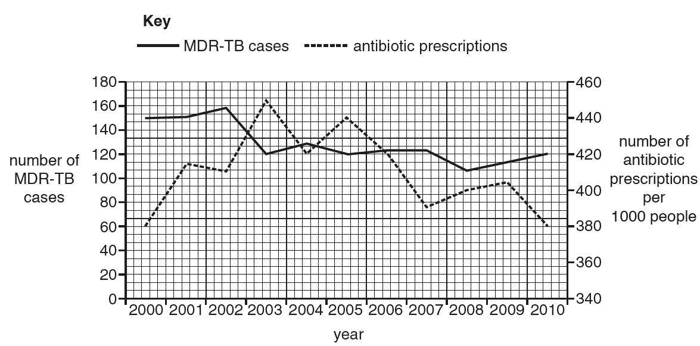
Fig. 7.1
(c) | Using Fig. 7.1, calculate the mean percentage decrease per year in the number of MDR-TB cases between 2000 and 2010.  Show your working.  Decrease in cases in 10 years = (150-120) / 150 x 100 = 20 %;  Decrease in cases per year = 20/10 = 2%;  To see workings, and statement that can be understood (no short form, delta, arrow down, unit signs) (minus 1m)  Answer = ……………2………. %

[2]

(d) | Scientists have concluded that the overuse of antibiotics will lead to an increase in MDR-TB cases.  Evaluate the validity of this conclusion using the data in Fig. 7.1.
Support
- Trend: Number of MDR-TB cases increases as prescription number increases;
- E.g. Between 2000 to 2002, number of MDR-TB cases increases from 150 to 160 as prescription number increases from 380 to 410;
Accept other relevant data that support trend 1 OR
 | - Trend: Slight decrease / no change in number of MDR-TB cases as prescription number decreases (e.g. 2003-2008 / 2009 / 2010)
- E.g. Between 2003 to 2008, number of MDR-TB cases decreases from 120 to 107 as prescription number decreases from 450 to 390;
Accept other relevant data that support trend 3 Either 1&2 OR 3&4, max 2;
Undermines
- Trend: Number of MDR-TB cases decreases even though prescription number increases;
- E.g. Between 2002 to 2003, number of MDR-TB cases decreases from 160 to 120 as prescription number increases from 410 to 450;
Accept other relevant data that support trend 5 OR
 | - Trend: Number of MDR-TB cases increases even though prescription number decreases (e.g. 2008-2010);
 | - E.g. Between 2008 to 2010, number of MDR-TB cases increases from 107 to 120 as prescription number decreases from 400 to 380;  Accept other relevant data that support trend 7 Either 5&6 OR 7&8, max 2; | [4]

Data from the graph (for marker)
Year | Number of MDR-TB cases | Antibiotic prescription per 1000 people
2000 | 150 | 380
2001 | 151 | 415
2002 | 160 | 410
2003 | 120 | 450
2004 | 128 | 420
2005 | 120 | 440
2006 | 124 | 420
2007 | 124 | 390
2008 | 107 | 400
2009 | 112 | 405
2010 | 120 | 380
Note: must include years, number of cases and number of prescriptions per 1000 for either support or undermines.
Note: Accept if students quote mid of years, e.g. mid 2000 to mid 2002, since x-axis uses 5 small squares for each year.
[Total: 12]

- Fig. 8.1 shows the position of two genes on three chromosomes II, III and IV of the fruit fly, Drosophila melanogaster.

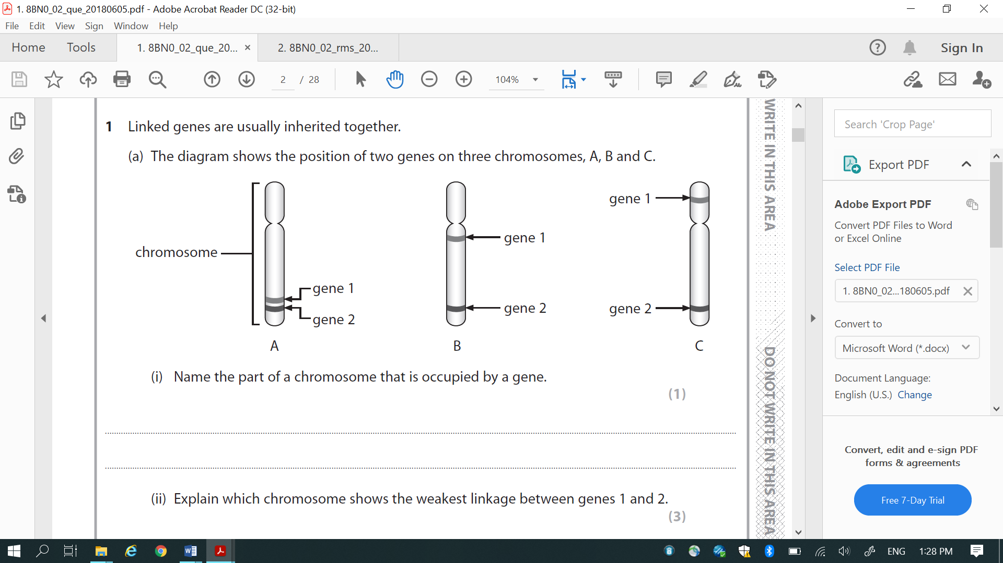
gene A
gene B
II
gene C
gene D
III
IV
gene E
gene F

Fig. 8.1
(a) | Explain which chromosome is most likely to show complete linkage between the two genes labelled in each chromosome.
 | - Chromosome IV;
 | - Genes E and F are positioned next to each other;
 | - Least likely to have chiasmata / lower frequency of chiasmata forming between them / be separated during crossing over;
 |  | [3]

A group of geneticists examining inheritance in D. melanogaster found that gene A and gene B on chromosome II codes for body colour and wing type respectively (Fig. 8.2). The two genes are 28 cM (centimorgan) apart. When they crossed a pure-bred brown-bodied, curved-winged fly with a pure-bred black-bodied, normal-winged fly, all the F₁ offspring produced were observed to have brown body and curved wings. They then proceeded to test cross an F₁ offspring with a fly homozygous recessive for both traits.
gene A
gene B
28 cM
II

Fig. 8.2
(b) | A recombinant frequency of 1% is defined as 1 cM distance between two genes on a chromosome. Recombinant frequency can be calculated using the equation:  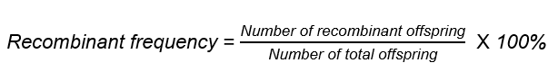  Table 8.1 shows the phenotypes observed in a total of 50 progeny from the test cross with the F₁ offspring.  Table 8.1  Using Fig. 8.2 and the equation of recombination frequency, calculate the expected number of progeny with each phenotype and complete Table 8.1. [1]
  phenotype | number of offspring
  brown body, curved wings | 18
  brown body, normal wings | 7
  black body, curved wings | 7
  black body, normal wings | 18
  total | 50

(c) | Using the letters A/a and B/b to represent the alleles of the two genes, illustrate the test-cross with the use of a genetic diagram.  Parental phenotype: Brown body, curved wings x Black body, normal wings  1. 1m for Parental genotype, with brackets indicating linked genes;  Parental genotype: (AB) (ab) x (ab) (ab)  Gametes (AB) (ab) (Ab) (aB) (ab)  2. 1m for circled gametes;  Recombinant gametes  3. 1m for offspring genotype with correct corresponding phenotype;  R! if 1:1:1:1 ratio is given  A! No ratio  Offspring genotype:  Note: No mark awarded if no brackets to show linked genes condition  [4]
  (AB) (ab)  F1 phenotype: | (ab) (ab) | (Ab) (ab)  Recombinant genotypes | (aB) (ab)
  18 Brown body, curved wings | 18 Black body, normal wings | 7 Brown body, normal wings | 7 Black body, curved wings  Recombinant phenotypes | 4. 1m for recombinant gametes / genotypes / phenotype mentioned;

(d) | Suggest how the allele for gene A gives rise to a brown body in D. melanogaster.
 | - Allele transcribed to mRNA and mRNA translated to protein / Gene A is expressed to form protein;
 | - Protein may be an enzyme that synthesises a brown pigment / a transcription factor that result in the expression of genes that allow for synthesis of brown pigment ;
 | - AVP (e.g. Inhibitor to inhibit a pathway that codes for an alternative colour); | [2]

[Total: 10]

- E-cigarette smoke (ECS) delivers nicotine as an aerosol without tobacco or the burning process. It does not contain carcinogenic by-products due to incomplete combustion and is thought to be less hazardous than combustible cigarettes.
To understand the carcinogenicity of ECS, a group of scientists investigated the effects of nicotine present in ECS on human lung epithelial cells.
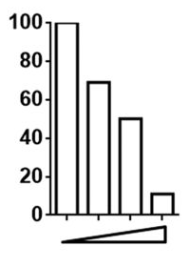
Fig. 9.1a shows the relative DNA repair activity in varying concentrations of nicotine.
Relative DNA repair activity

Concentration of nicotine

Fig. 9.1a

Fig. 9.1b is the ethidium bromide-stained gel electrophoregram showing the amount of DNA coding for the XPC protein produced in varying concentrations of nicotine. This is indicative of the abundance of XPC, a crucial protein involved in DNA repair.
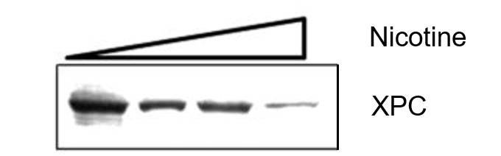
Fig. 9.1b

Colony formation on soft agar can be used to assess anchorage-independent growth. Fig. 9.2 shows anchorage-independent growth of lung cells on soft agar in the absence and presence of nicotine.
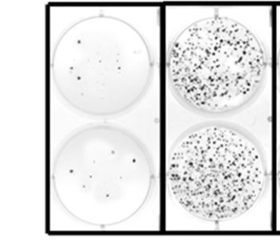

Control
Nicotine

Fig. 9.2
(a) | (i) | Define the term cancer.
 |  | - Genetic disorder/accumulation of mutations in a single cell lineage leading to uncontrolled cell division;
 |  |  | [1]

 | (ii) | With reference to Fig. 9.1 and 9.2, explain how ECS may promote lung cancer development.
Data from Fig 9.1
- (From Fig. 9.1a), High nicotine in ECS promotes lung cancer development by reducing relative DNA repair activity from 100 to 10 (A! 9-11);
- (From Fig. 9.1b), Nicotine in ECS promotes lung cancer development as XPC repair protein is less abundance / lower amount of DNA coding for XPC protein at high nicotine concentration;
“High” marked once
- Resulting in an increase in the rate of mutations accumulating in a single/same/one cell lineage;
- Cells with damaged DNA continue to divide and bypass cell cycle checkpoints;
Data from Fig 9.2
- *Nicotine in ECS resulted in increased number of cells showing anchorage-independent growth on soft agar / lack of anchorage dependence compared to control in Fig. 9.2;
 |  | - Which is a trait/ hallmark of cancer cells, allowing for metastasis to occur;
 |  | Must quote data from Fig 9.1a/b (pt 1 or 2) + data from Fig. 9.2 (pt 5) to score full credits  @1m each, max 5 | [5]
Nicotine is also known to increase the release of norepinephrine and epinephrine from nerve terminals. The binding of these chemicals to β-adrenergic receptors stimulates processes related to tumour progression as shown in Fig. 9.3.
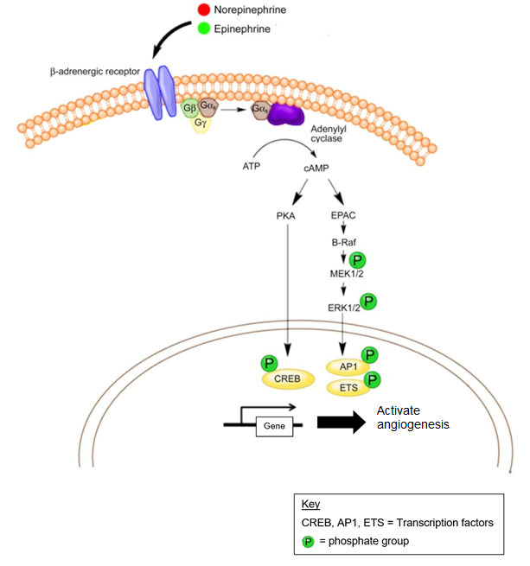
Fig. 9.3

(b) |  | Proteins known as β-blockers are used specifically to bind and inhibit β-adrenergic receptors.  With reference to Fig. 9.3, explain how β-blockers can be used to treat cancer.
 |  | - Inhibition of B-adrenergic receptor prevents activation of G protein;
 |  | - Adenylyl cyclase cannot be activated and cAMP (second messenger) is not synthesised;
 |  | - PKA / EPAC are not activated, no phosphorylation cascade;
 |  | - lack of transcriptional activators/ factors (quote at least 1 e.g. CREB, AP1, ETS) for transcription of genes involved in angiogenesis;
 |  | - Cancer cells cannot proliferate due to lack of angiogenesis / nutrients or O₂ / unable to remove waste products;
 |  | @1m each, max 4 | [4]

[Total: 10]

- Climate change is one of the biggest concerns in today’s world. Increased temperatures and extreme weather events has had severe effects on plants and animals globally.
(a) | Explain how human activities have led to increased temperatures.
 | Question removed due to CLT
 |  | [2]

Scientists are starting to see changes in plant morphology due to climate change. A recent study documented how more flowers have increased UV-absorbing pigmentation as protection against the sun’s radiation. One example of such a flower is the alpine cinquefoil.

(b) | Explain how high levels of UV-absorbing pigmentation in flowers became common in a population of alpine cinquefoil.
 | - Variation exists in a population of alpine cinquefoil plants with flowers with different amounts of UV-absorbing pigmentation;
 | - The selection pressure is increased UV radiation ;
 | - Alpine cinquefoil plants with flowers that have higher levels of UV-absorbing pigmentation are selected for;
 | - These plants have higher reproductive success and can pass on the allele coding for higher UV-absorbing pigments / proteins involved in synthesis of UV-absorbing pigments / flower colour to their offspring;
 | - Over time, the frequency of allele coding for higher UV-absorbing pigmentation increases in the gene pool of population of alpine cinque plants;
 |  | [5]

While having more UV-absorbing pigmentation helps protect the pollen of the flowers from damage, scientists are worried about the negative downstream effects.

Hoverflies, the flower’s natural pollinators, navigate their way to pollen by sensing UV light. More UV-absorbing pigments changes the way hoverflies perceive flowers. Fig 10.1a and 10.1b show samples of alpine cinquefoil flowers collected 60 years ago and recently under UV light respectively. Dark petal areas possess UV-absorbing compounds whereas lighter areas are UV reflective.

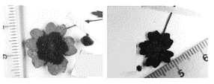
Fig 10.1a Fig 10.1b

(c) | With reference to Fig 10.1, suggest how the change in pigmentation might affect the plant population.
 | - Hoverflies can no longer detect the flower as it is too dark;
 | - Flowers would not be pollinated and hence plants cannot reproduce since fruits cannot form / plant population size expected to decrease;
 |  | [2]

[Total: 9]

- The administering of COVID-19 vaccinations requires two shots – a first dose and a booster dose. Fig. 11.1 shows the share of people partly and fully vaccinated against COVID-19 in some countries over a period of five months until May 2021.
By May 2021, the daily new confirmed COVID-19 cases is 30 per million people in United Kingdom and 230 per million people in India.
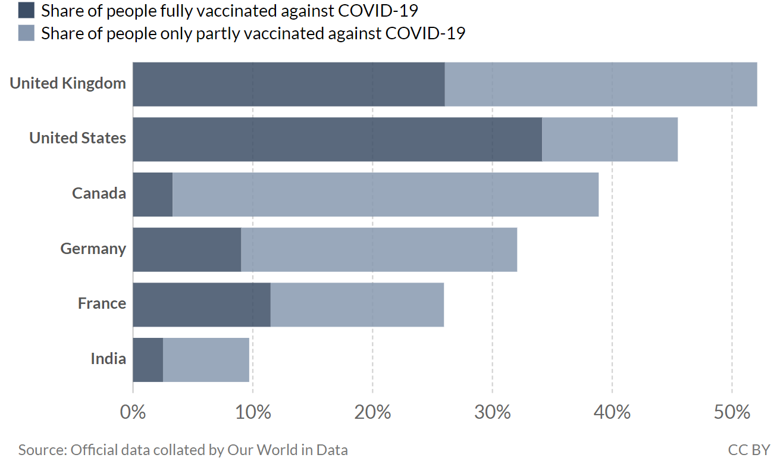
Fig. 11.1
(a) | With reference to Fig. 11.1, explain why infection rate in UK is low while it is high in India.
- Data:
52 or 53% of people partly and fully vaccinated in UK whereas only 9 or 9.5% of people partly and fully vaccinated in India OR
26 or 27% of people are fully vaccinated in UK whereas only 2 or 3% fully vaccinated in India OR
only 26% (A! 25-27%) of people are partly vaccinated in UK, whereas only 7% (A! 6-7.5%) of people are partly vaccinated in India;
- [effect of vaccination on individual] Partly and fully vaccinated people are less likely to be infected / presence of antibodies / memory B and T cells specific to the virus;
- [effect of vaccination on populations] Infection rate in UK is low due to herd immunity which limits the spread of disease;
- [Reason for low vaccination rates] High infection rate in India as mass vaccination programmes are slow to roll out/ limited vaccines available in India/ limited resources;
 |  | [[[[3]

(b) | State two significant difference between the primary and secondary immune responses after the COVID-19 vaccinations.
 | Primary immune response | Secondary immune response
1. | Longer lag time before / Delayed / Slower antibody secretion after antigen exposure | Faster secretion of antibody 5 days after antigen exposure;
2. | Ref. to the idea lower amount antibody or magnitude of response (as compared to secondary immune response) | higher amount of antibody / stronger response;
3. | Short term effect of primary response; | Prolonged effect of secondary response;

 | @ 1m | [2]

[Total: 5]

END OF PAPER

